Calculus 3
Exam 1 Web Based Sections ~ SUMMER 2025

Scoring Rubric: Points are awarded according to the following guidelines.

- 4 points may be awarded for a response that includes a perfect answer with all major steps shown that leads to the answer. Minor calculations may be omitted.

- 3 points may be awarded for a response that includes a incorrect answer due to a minor miscalculation where the correct method is used. Alternatively, 3 points may be awarded for a correct answer that omits a major step.

- 2 points may be awarded for a response that includes an incorrect answer given due to a major mathematical error in calculation. Alternatively, 2 points may be awarded for
an answer that omits several major steps. Another scenario that may lead to 2 points being awarded is one where an answer is provided but the method used is not the one that is specified in the problem. Note: An incorrectly placed negative or positive sign is not necessarily a minor error; it could be a major error.

- 1 point may be awarded for a very minimal response that references a correct method. i.e. a response that references a correct theorem but does not provide any details as to how a solution may be obtained. Alternatively, 1 point may be awarded for a response that includes only a correct answer with no or very few key steps shown.

- 0 points are awarded for a completely incorrect response.

1a) The vector u has initial point (3, 4, 8) and terminal point (9, 2, 12). Compute u.
1b) The vector v has initial point (-1, 7, -4) and terminal point (-10, 12, -1). Compute v.

2. The distance between the points (1, -4, 5) and (2, -3, x) is equal to 9 units. Find the value of x. Round your answer to two decimal places.

3. Given 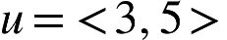and 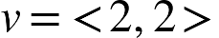Find u · v, u · u, ||u|| and ||v||^2

- Consider the vectors 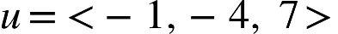 and 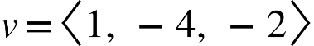
Compute u ✕ v.

- Find the angle 𝜃 between the vectors in degrees.
u = 5i - 9j - k
v = 2i − 8j

- Determine whether the given point lies on the line. If it is on the line, explain how you know this. If not, explain how you know this.
x = −1 + t, y = 5t, z = 3 + t

- (1, 10, 5)

b) (1, 0, 3)

- Find a set of parametric equations that passes through the given point and is parallel to the given vector. Point: (2, 8, 5), Vector u = <-3, 4, -1>. Find another point on the line,

- Determine the domain of the vector valued function 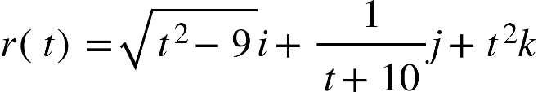

- Represent the line segment from P to Q by a vector-valued function. (P corresponds to t = 0. Q corresponds to t = 1.) P(−5, −5, −3), Q(−2, −4, −7)

- Given and Compute 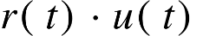.

- Given . Compute 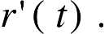

- The position vector r describes the path of an object moving in space. Given . Compute
- v(t) then compute v(1).
- s(t) (speed) then compute s(1).
- a(t) then compute a(1).

- Given the points (1, 2, 6), (-4, 6, 9) and (2, 5, 3). Determine the equation of the plane that passed through all three points.

